EdTech concept document

Contributors:

Shallwin Silvania – [shallwinsilvania@gmail.com](mailto:shallwinsilvania@gmail.com) | +31 0616866849

|  |  |  |
| --- | --- | --- |
| **Version** | **Date:** | **Changes:** |
| Incomplete V1.0 | 22-9-2022 | Start. |
| Incomplete V1.1 | 26-9-2022 | MoSCoW, Description. |
| Incomplete V2.0 | 1-10-2022 | Concept Start. |
| Incomplete V2.1 | 6-10-2022 | Concept Boards finished; Sketches made for object. |
| Incomplete V3.0 | 14-10-2022 | Fix according to feedback. |

Contents

Introduction 4

MoSCoW 5

Object concepts 6

Object Design 6

Object Interactive Functions 7

Object Interactive Feedback 9

Connection concept 11

Controller medium 11

Controller Communication Protocol 11

Conclusion 12

# Introduction

The purpose of this document is to show the concepts behind the EdTech project. In this document the design, interactions (inputs), outputs & connectivity will be analyzed for the EdTech project. The project is to design an interactive object that will be used by primary school students in the lower group. The goal of the project is to have an interactive “layer” between student and teachers meaning that student and teachers will be able to communicate with each other through this object.

# MoSCoW

The only requirements that were mentioned during the meeting was that the object must be connected in one way or another to something of the teachers (whether that is another interactive object or PC was not made clear). Based on this requirement and personal experience (babysitter) the following MoSCoW was made:

*Must*

* Interface with a device of the lecturer
* Have an adequate size
* Have easy to understand/learn interactions

*Could*

* Have a way to check attention level of the student
* Help students with basic questions

*Should*

* Have interactive elements that don’t take away too much attention
* Have an elegant yet childish design
* Be durable

*Would / Won’t*

* Have a personality
* Reward system

# Object concepts

## Object Design

* Simple
* Childish
* Unisex
* Feasible

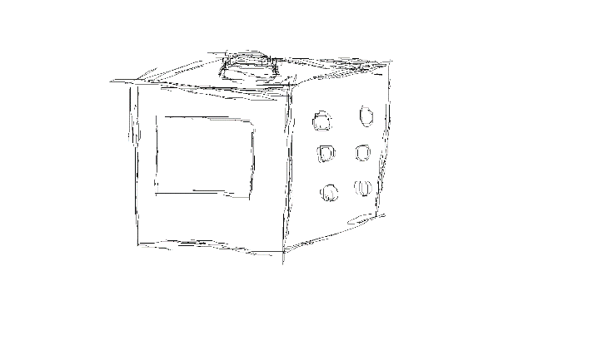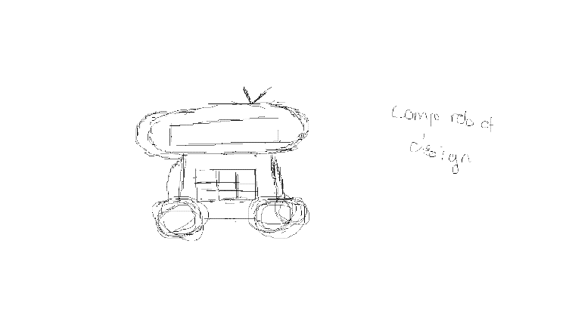

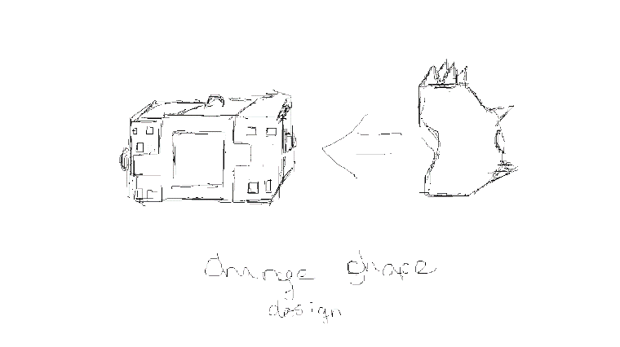

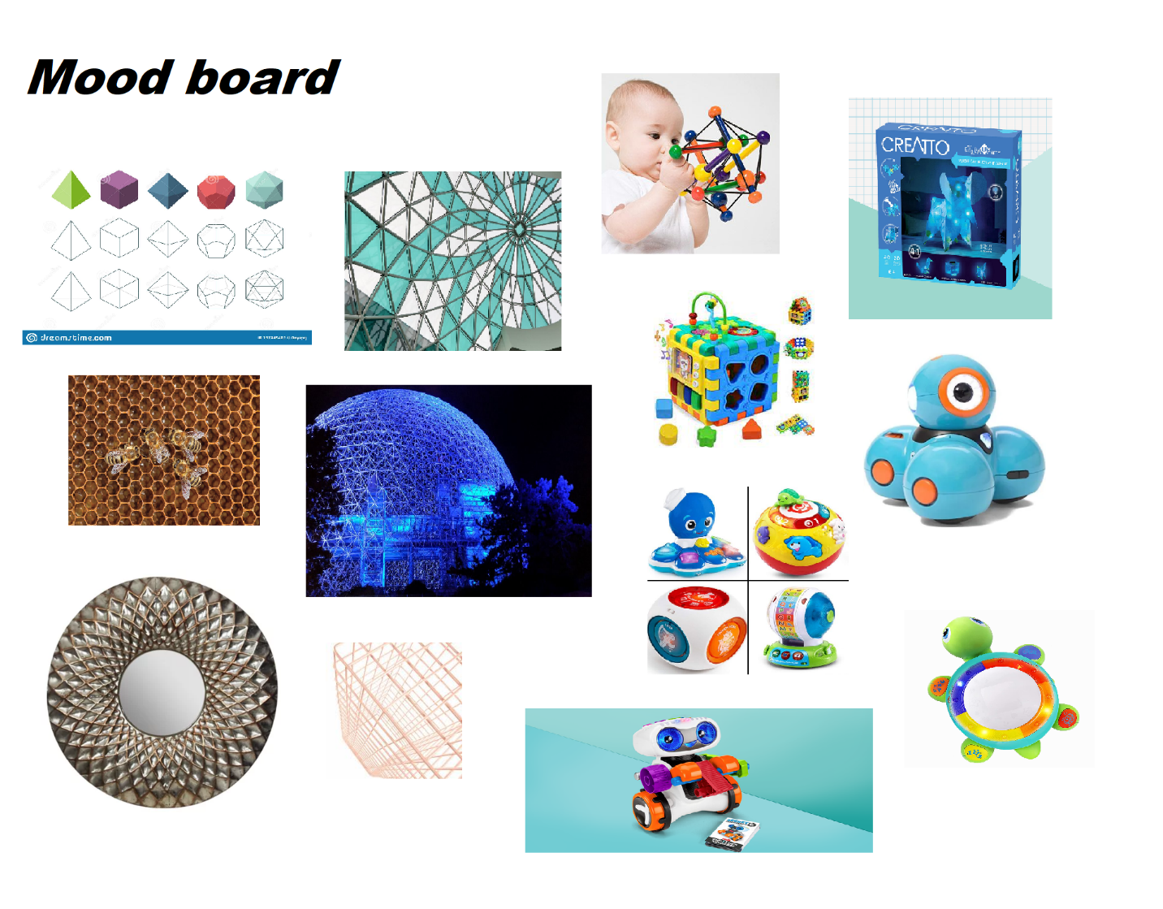

## Object Interactive Functions

* Sense for questions
  + Tap side to ask questions
* Sense for answer (A, B, C example)
  + Tap a side to give an answer
  + Write letter of the answer
* Sense for mood of the day/hour
  + Hold to fill a happiness bar
  + Tap a side to choose a mood (Happy, sad, angry etc.)
* Sense for games
  + Learn compassion/responsibility through taking care of the object (Compassion/Ethics)
  + Control a character/object in a game (external) that could be projected (Community building)
  + Tap numbers to form a bigger number (Math & logic)
  + Write missing letter (Grammar & writing proficiency)
* Sense for difficulty ranking
  + Hold for difficulty bar
  + Tap side for a number
* Sense for teacher ranking
  + Tap for a rank

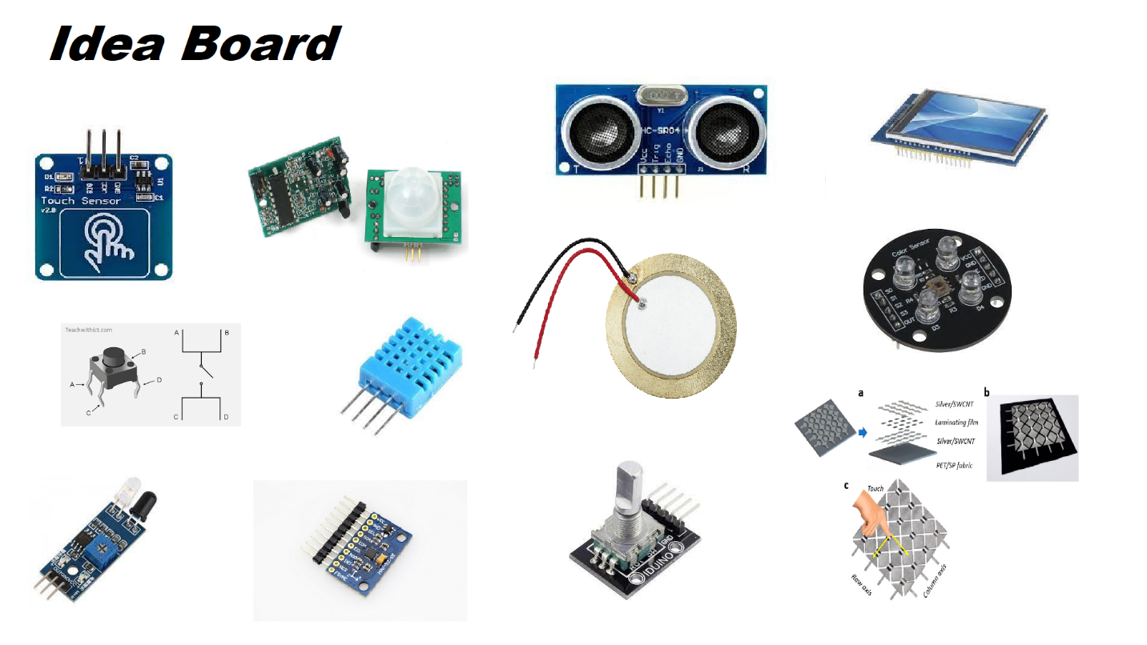

* Touch/Piezo/Button
  + Tap/hold for function
    - Question (Tap when I have a question)
    - Answer (Tap side with answer, Keep tapping to increase/decrease answer value (Math))
    - Games
* Ultrasonic/IR sensor/PIR
  + Hand detection for function
    - Question (Hand gesture when I have a question)
    - Answer (Wave on the side of correct answer)
    - Games
* Rotary encoder
  + Twist to for function
    - Answer (Fill answer gauge)
    - Rating (Fill rating gauge)
* Color sensor
  + Detect color for function
    - Answer (True or False, Colored answer cards)
    - Games
* Accelero & Gyro sensor (MPU)
  + Sense object rotation
    - Answer (Turn to side with correct answer)
  + Sense object lift/drop
    - Question (Lift when need to ask a question)
  + Sense object displacement
    - Question (Move to a side on table for question)
    - Answer (Move object to a side on the table to answer question)
* Temperature/Humidity sensor
  + Detect when user blows on the object
    - Games
* Touchscreen
  + Write answer
    - Answer (Write letters/numbers to answer questions)
  + Tap for answer
    - Answer (Tap correct answer)
    - Ranking (Tap rank)

## Object Interactive Feedback

* Light up LED and/or play sounds/vibrate when an answer is correct/incorrect
* Display mood (Face, Bar, or both)
* Display object mood (A face for the object)
* Display numbers & letter

* LED-Matrix & LED-strips
  + Display (Mood, Answer correctness)
* Haptic buzzer
  + Actuate (Vibrate if answer is wrong)
* Servo
  + Actuate (Rotate/move part when gesture is inputted)
  + Sound (Robotic sounds)
* Speakers
  + Sound (Correct/Incorrect notification, play sounds for mood)
* OLED & LCD (Touch)
  + Display (Answers, Questions, users’ answers, Mood, Object mood)

# Connection concept

## Controller medium

* Mobile Application (Android/IOS)
* Desktop Application
* Web Application
* Another object

## Controller Communication Protocol

Based on research done on IoT protocol (for the Swarm Robotics project (link)). I selected the protocols that could be used for this device. Bluetooth is the only short-range protocol that did not make the list due to its connection count limitation (only 7 connections allowed to a device).

# Conclusion

..